San Jose State University

EE250 (Section 2) Fall 2019 Prof. Kamali

Problem Set #4

- Problem 4.67
- Problem 4.78
- Problem 4.91
- Problem 4.100
- Problem 4.104
- Problem 4.119
- [Midterm, Fall 2011] The DC power dissipated in a resistor is 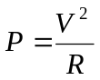where 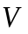is the voltage across . Let us assume 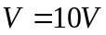and has a uniform distribution between 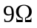and 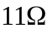. Find the pdf of the dissipated power .

- [Midterm, Spring 2009] In wireless systems with smart antenna, there are more than one channel between the transmitter and the receiver and the latter can use both received signals to improve its estimate of the transmitted message. Consider the following system where 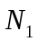and 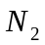are two independent noise sources which are zero mean and unity variance Gaussian random variables. The input can be +1 or -1 and 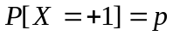. The input is naturally assumed to be independent of and .

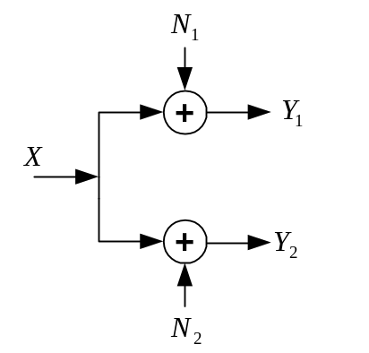

- Find 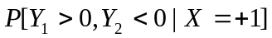 and 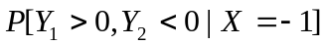.
- Find 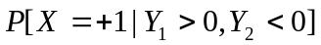.
- If 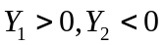, what is the best estimate of if 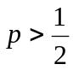and if 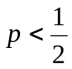.
Hint: 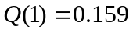

- [Midterm, Fall 2009] Suppose the input to an Analog to Digital Converter (ADC)is a continuous random variable with pdf 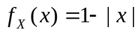 for 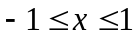. What dynamic range  must be chosen for ADC to keep the probability of clipping at 4% (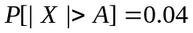)?

- [Midterm, Spring 2009] The pdf of a continuous and non-negative random variable satisfies the following equation.

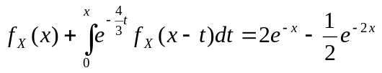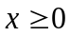

Find 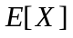and 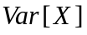.

Hint: First find the Laplace Transform of 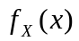.

- [Midterm, Spring 2014] The Probability Generating Function (PGF) of the discrete random variable 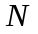 is 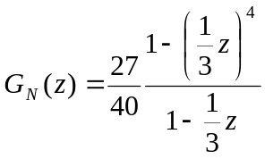.

a) Find the probability mass function (pmf) of .
b) Find 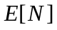.

- [Midterm, Fall 2015] Find the pdf of 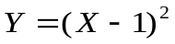 if is a uniform random variable between 0 and 2.

- [Midterm, Fall 2017] Consider a communication channel whose output is related to its input through the following equation.

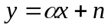

where 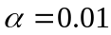is the channel gain and is a zero mean Gaussian noise with the standard deviation of 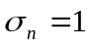mvolt. Input signal is one volt. At the receiver, an Analog to Digital Convertor (ADC) converts to digital. When designing ADC, we fix its input range and when the input signal () exceeds the range of ADC, clipping happens which is undesirable. Find the probability of clipping if the ADC range is 15mvolts.

Q Function
